Hemlock Township Supervisors
Regular Monthly Meeting
April 10, 2018

Call to Order
Approve March minutes

Reports:
- Solicitor
- Police

- Zoning Officer
- Planning Commission
- Park Committee
- Sewage Enforcement Officer

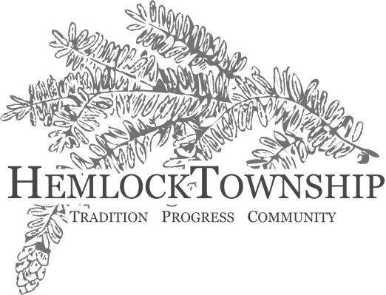

- Roadmaster
- Emergency Mgmt. Coord
- Township Manager

Citizen’s Comments

Old Business

New Business
- Consideration of Resolution 04-10-2018, Approving Transfer of Liquor License No. R-13554
- Consideration of bids for road material delivery and equipment rental
- Consideration of bids for pipe for Snyder Dr. Project
- Discussion on Deferred Retirement Option Program (DROP)
- Consideration of FMLA request

Other Business

Approve Bills as Posted

Adjournment of Meeting

