Hemlock Township Supervisors
Regular Monthly Meeting
January 3, 2017

Call to Order
Approve December minutes

Reports:
- Solicitor
- Police

- Zoning Officer
- Planning Commission
- Park Committee
- Sewage Enforcement Officer

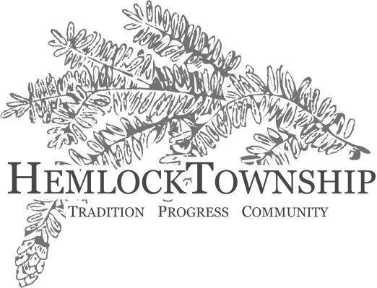

- Roadmaster
- Emergency Mgmt. Coord
- Township Manager

Citizen’s Comments

Old Business

New Business
- Harbor Freight Update
  - Application for Traffic Signal Approval; Resolution 01032017
- MS4 Update

  - Appoint Representative to the County’s MS4 Workgroup

- Cable Franchise Proposal for Franchise Fee Audit Services

- Consideration of Zoning Permit Fee Waiver: Pavilion in Fernville Park

- Workshops for Zoning Ordinance Amendment Review

Other Business

- PSATS conference, April 23-26, 2017

Approve Bills as Posted

Adjournment of Meeting

